总结报告5

（2019.9.20——2019.9.21）

**一、学习内容：机器学习中的数学：多元微积分WEEK1,WEEK2；**

**机器学习WEEK1（2）：Cost Function**

1. **函数、导数的概念**

Local gradient(梯度，变化率)：the limits of rise over run operation

注：premature(过早的) optimization is the root of evil.

1. **Derivative of multivariable/multivariate**



**3、The Jacobian**

（1）meaning

Jacobian describes the gradient of a multivariate system.

（2）partial derivatives（偏导）Write as a row vector：



is a vector pointing in the direction of stepest slope of the function.The steeper the slope, the greater the **magnitude** of Jacobian at that point.

1. **The Jacobian applied：from vectors up to matrices**

 

**Notice: Smooth function**: if we zoom in close enough, we can consider each little region of space to be approximately linear.

**例：笛卡尔坐标系（Cartesian）极坐标（Polar coordinate system）**

**4、The Hessian: a simple extension of the Jacobian vector**

For the Jacobian, collecte together all of the first order derivatives of a function into a vector.

For the Hessian, collect all of **the second order derivatives** together.

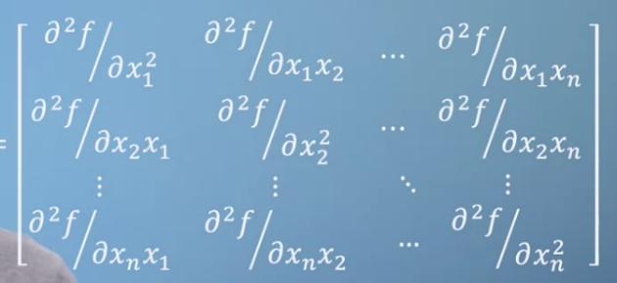

H=

**Notice：**If the function is continuous，the Hessian is symmetrical(对称阵).

1. **Machine Learning：Cost Function**

(1)Notation:

m= number of training examples

x = ” input” variable/feature

y =” output” variable/”target” variable

(x,y) = a single training example

training example

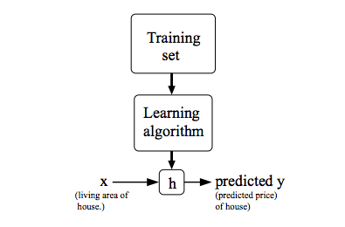

h: hypothesis，. Linear Regression with one variable(Univariate 单变量的linear Regression)

shorthand: . ：parameters

(2)Cost Function :

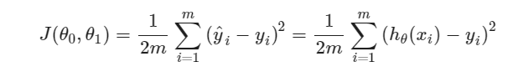

GOAL: ，使得均方误差最小。

I,，总经过原点。

II,contour plots/figures(等高线)。

